
School of Engineering and Digital Sciences
Master of Engineering Management
EMEM 539
Big Data and Information Management

Individual Portfolio
Course Instructor: Georgios Dafoulas
Submission by: Miras Mels
Student ID: 202010679

Nov. 16 2025

Section 1

Part 1. Five out of ten V’s of big data.
Big Data is characterized by attributes that define its complexity and scale, often referred to as the "Vs." While early definitions focused on three, modern conceptualizations extend to ten. Relating to the World Bank population estimates dataset, five key Vs are explained below.
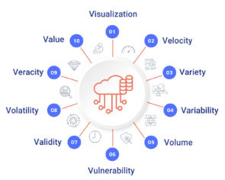Figure 1. 10 V’s of Big Data
- Volume: Refers to the immense scale of the data. While the provided CSV is a modest snapshot, the full World Bank data repository comprises historical time-series data for thousands of indicators across over 200 countries and regions, resulting in an enormous volume of information.
- Velocity: Refers to the speed at which data is generated, collected, and processed. The World Bank constantly updates its data based on new reports, censuses (Latest population census), and surveys, requiring high-velocity data ingestion and processing to ensure reports and economic indicators remain current.
- Variety: Describes the diverse nature of the data, which can be structured, semi-structured, or unstructured. The dataset features:
  - Structured Data: Columns like Country Code, Region, and Income Group are clearly categorized.
  - Unstructured Data: The Special Notes column contains free-form text detailing country-specific exceptions, which requires advanced parsing to analyze.
- Veracity: Focuses on the quality, accuracy, and trustworthiness of the data. This is a critical challenge, as evidenced by the high number of missing values (e.g., the entirely null Alternative conversion factor column) and the Special Notes mentioning issues like "multiple or dual exchange rate activity exists," which directly impacts the reliability and comparability of cross-country figures.
- Value: Is the ability to convert raw data into meaningful and actionable insights. The data’s ultimate value is realized when it is analyzed to inform global development policies, set loan conditions (Lending category), and guide resource allocation decisions for millions of people worldwide.

Part 2. Stages of the Information Management Journey
The Information Management (IM) journey reflects the entire lifecycle of data within an organization, from creation to disposal. This journey is typically broken down into four key stages: Gathering, Storing, Distributing, and Deleting.
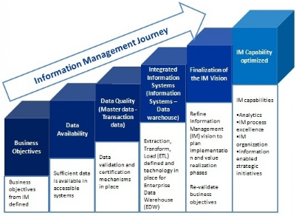Figure 2. Stages of Information Management.
The transition across these stages reflects an evolution from mere data collection to active data governance.
The 4th Stage: Deleting (or Data Destruction/Archiving) is especially crucial as it completes the information lifecycle and ensures responsible data management. This stage is not merely about removing files but is a strategic step that manages data Volatility and Vulnerability (security), aligning with modern data governance practices.
For the World Bank, the "Deleting" stage involves critical policy decisions. As new data is gathered (e.g., a more recent Latest population census), older, less relevant, or politically sensitive data must be:
- Archived: Older national accounts figures are often preserved for historical studies and economic modeling.
- Purged: Raw, highly confidential source data (like individual survey responses) may need to be securely deleted according to a country’s privacy laws.
- Governed: Specific data points, like the outdated or problematic exchange rates mentioned in the Special Notes, must be managed to prevent misuse, reinforcing the data’s veracity in current analyses. This ensures that the organization is not liable for retaining information past its legal or practical retention period.

Part 3. Overview of the analytics process model.
The analytics process model is a structured methodology for turning raw Big Data into actionable intelligence. The steps are iterative and ensure a systematic approach to extracting Value from data.
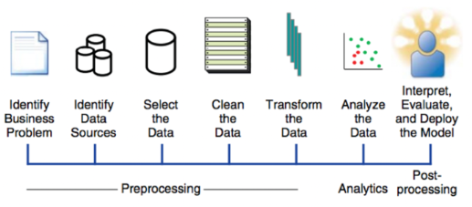 Figure 3. Analytics Process Model
The primary stages of the model are:
- Collect Data / Define Objective: The process starts by clearly defining the business question (e.g., "Which lower-middle-income countries require urgent aid?") and then acquiring the necessary datasets. This aligns with receiving the World Bank dataset.
- Process and Clean Data: Raw data is rarely usable and must be prepared (scrubbed) to ensure quality. This is a vital step for the World Bank data, involving:
  - Imputation: Addressing the numerous null values in columns like Latest industrial data.
  - Transformation: Using alternative conversion factors, as suggested in the Special Notes, to harmonize data for cross-country comparisons.
  - Deduplication/Standardization: Ensuring regional aggregation rows (AFE, AFW) do not skew analysis when focusing on individual countries.
- Analyze Data: Advanced analytical techniques, such as descriptive, diagnostic, predictive, and prescriptive analytics, are applied to discover patterns and insights. In this context, analysts would use the cleansed data to segment countries by Income Group (descriptive) or build models to predict a change in a country’s Lending category (predictive).
- Share Results / Act: The final stage involves interpreting the findings and communicating the insights via reports, visualizations, and tools to enable data-driven decision-making. The World Bank uses these results to act upon the analysis by setting economic policy and recommending aid to the respective countries.

Section 2

Part 1. Key differences of two suitable tools for each step of the Big Data workflow.
The Big Data workflow can be segmented into three core steps: Integration, Storage, and Processing (Slide 5). Each step requires distinct tools, and their selection is critical for optimizing performance for the World Bank's global data operations.
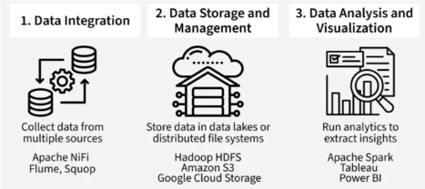
Figure 4. Big Data workflow.
The workflow requires hybrid tools for Integration, Storage, and Processing . For Integration, the World Bank pairs Sqoop for bulk historical census data transfer with NiFi for real-time economic indicator flows. Storage contrasts HDFS (for on-premise batch processing) with Amazon S3 (for scalable, cloud-native data lake hosting of assets like the Population-EstimatesCountry.csv). Processing is similarly split between Spark (general batch ML) and Flink (specialized, low-latency streaming), ensuring both complex historical modeling and real-time anomaly detection can be performed.
Data processing approaches are fundamentally distinguished by latency . Batch Processing operates on bounded data with high latency, making it ideal for generating definitive annual reports and determining a country’s final Income Group. In contrast, Stream Processing handles unbounded data with low latency, which is essential for real-time decision-making and monitoring dynamic economic data, like the currency issues noted in the Special Notes, where immediate response is required.
The most suitable starting point on the analytics maturity curve is a solid foundation of Descriptive (What happened?) and Diagnostic (Why it happened?) Analytics . These steps are vital for ensuring data veracity, such as inspecting missing values and analyzing the context provided in the Special Notes. This necessary foundation then enables the strategic, higher-value goals of Predictive (forecasting development status) and Prescriptive (determining optimal lending policies).

Part 2. The benefits of the different Big Data Processing approaches.
Big Data Processing approaches are primarily differentiated by latency and the nature of the data flow (time of processing), as detailed in the lecture (Slides 25-27). The two main approaches are Batch Processing and Stream Processing. While the Centralized and Distributed big data processing are the architecture based approaches.
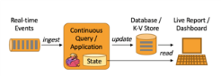
Figure 5. Stream Big Data Processing
Batch Processing:
- Time of Processing: High Latency (minutes to hours). Data is processed in large, bounded chunks that have accumulated over time.
- Benefits: High throughput, high accuracy due to operating on complete datasets, and efficient use of compute resources.
- Relevance to Case Study: Ideal for the World Bank's historical analysis and static reporting. It is used to generate final, definitive annual reports, such as determining a country's official Income Group based on finalized, batched economic data.
Stream Processing:
- Time of Processing: Low Latency (seconds to milliseconds). Data is processed continuously as it is generated in an unbounded flow.
- Benefits: Enables real-time decision-making and immediate response to events.
- Relevance to Case Study: Crucial for monitoring high-velocity data, like the real-time currency exchange rate fluctuations and related economic anomalies noted in the Special Notes column, allowing the World Bank to react instantly to unfolding economic crises.
The World Bank ultimately needs a hybrid Lambda architecture to leverage the benefits of both: using batch processing for long-term trend analysis and historical accuracy, and stream processing for real-time decision-making.

Part 3. Review of Data Analysis Techniques.
Data analysis techniques (Slide 32) follow a maturity curve where each technique builds on the findings of the previous ones. The four main types—Descriptive, Diagnostic, Predictive, and Prescriptive—answer increasingly complex questions.
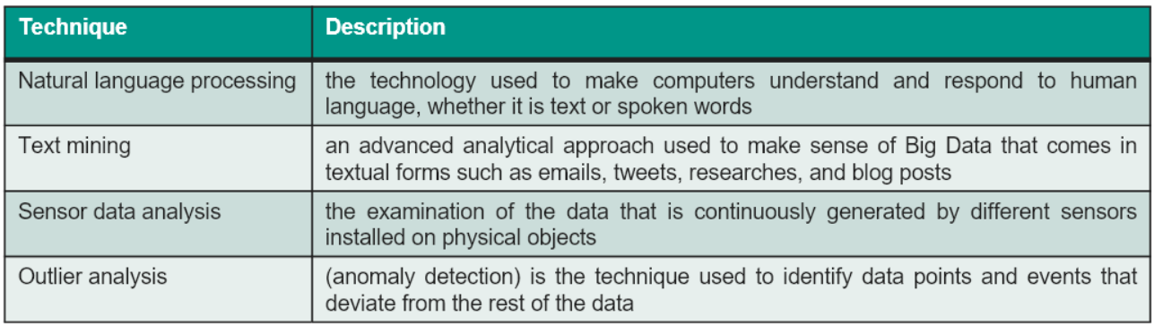
Figure 6. Data analysis techniques table.
For the World Bank population estimates case study, all four techniques have a role, but Descriptive and Diagnostic analytics are the most suitable starting points and form the foundation for all others.
- Descriptive Analytics ("What happened?"): This is the most suitable initial technique. It summarizes the dataset to understand the current global development landscape.
  - Example: Calculating the total number of countries in the Lower middle income group, or summarizing the distribution of Latest population census years to identify data gaps. This relies on the raw data in the CSV.
- Diagnostic Analytics ("Why did it happen?"): This builds on descriptive results to investigate the cause of an outcome.
  - Example: Investigating why specific data points are missing (high null counts in columns like Latest agricultural census) or why a country is in a certain Lending category, often by analyzing the textual data in the Special Notes.
The organization's strategic goal, however, lies in the advanced stages:
- Predictive Analytics ("What will happen?"): Using historical data to forecast future trends, e.g., predicting when a country’s economic growth will move its Income Group category.
- Prescriptive Analytics ("What should we do?"): Recommending the optimal action to achieve a goal, e.g., determining the best type of loan (Lending category) and amount of aid to prescribe to a country to ensure it moves from 'Low income' to 'Lower middle income.'
The data analysis strategy must begin with a strong Descriptive and Diagnostic foundation to ensure the veracity of the data before building complex Predictive and Prescriptive models for policy-making.

Section 3.
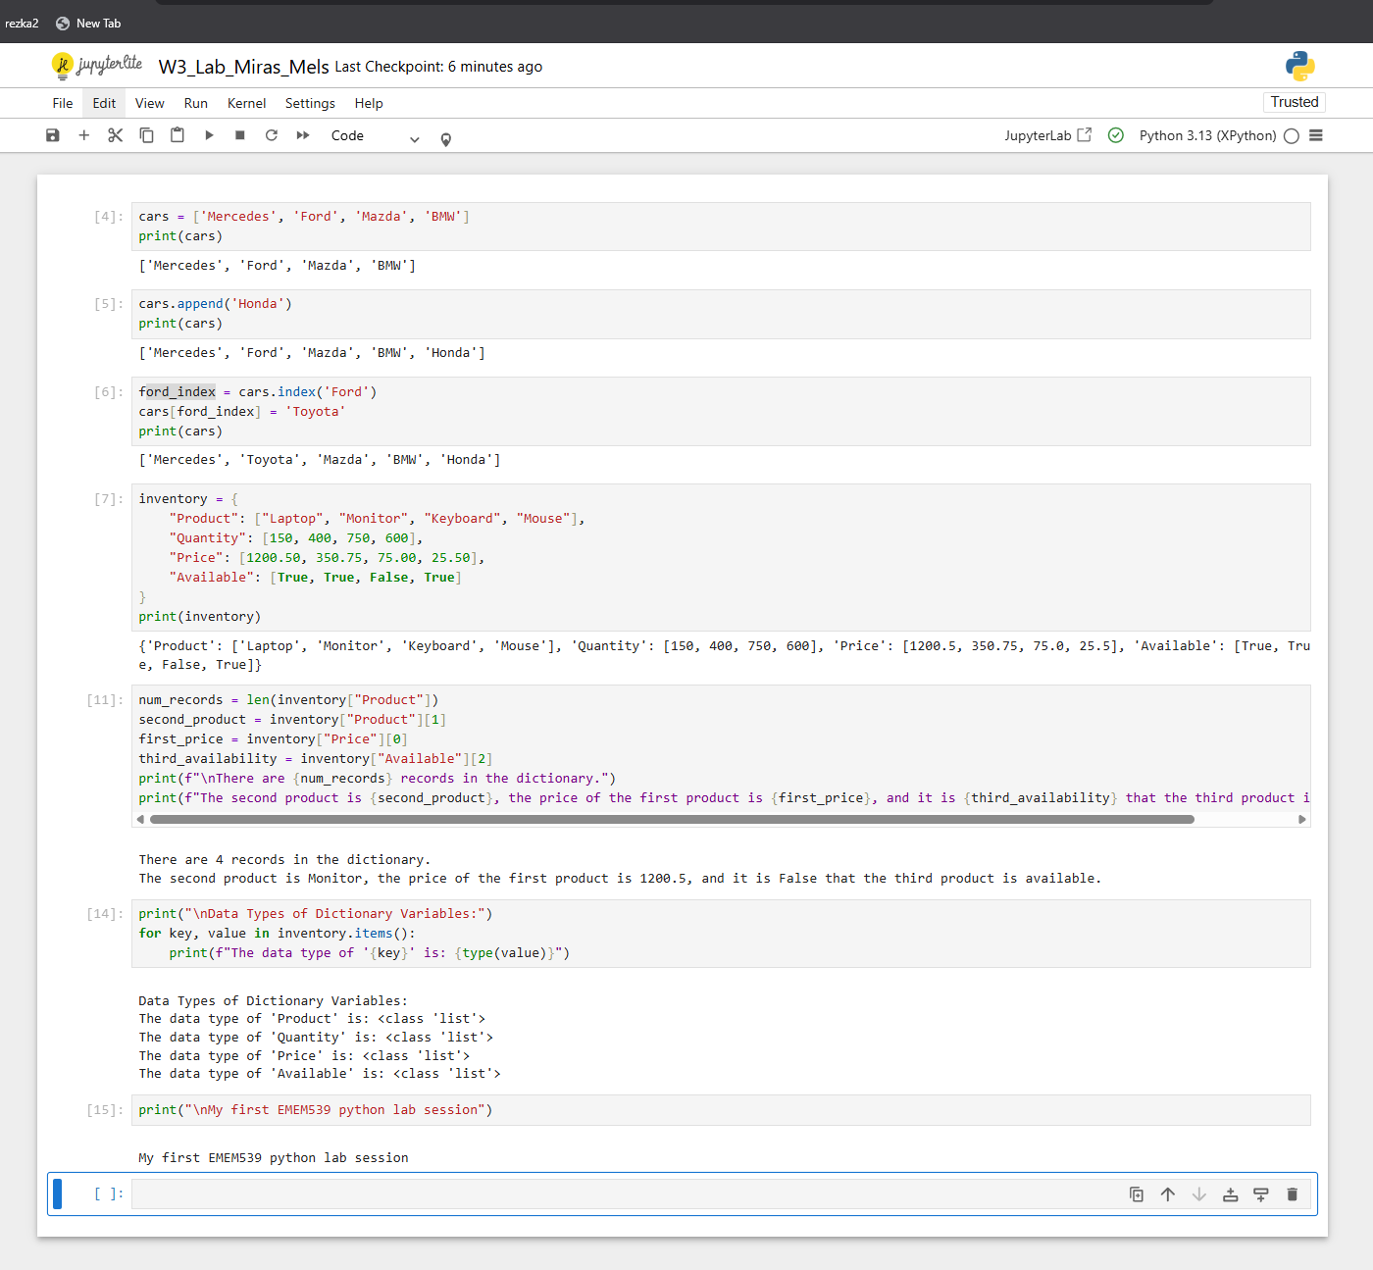
Figure 7. Screengrab of the jupyter notebook.
I finished the lab by using basic Python structures like lists and dictionaries. First, I worked with a list of car brands. I added Honda using append(), and then used indexing and the index() method to find Ford and replace it with Toyota. Then I created a dictionary called inventory, where each key (Product, Quantity, Price, Available) pointed to a list of values. This acted like simple data records. I accessed specific items using normal list indexing, like inventory["Product"][1]. I also used an f-string to combine text, numbers, and a boolean into one clean output sentence. After that, I checked the data types with type() to confirm that each main variable was a list, just like columns in a table. Finally, I printed the required message in step 7 to show that the lab was completed.

Section 4.

Part 1. Simple functions.
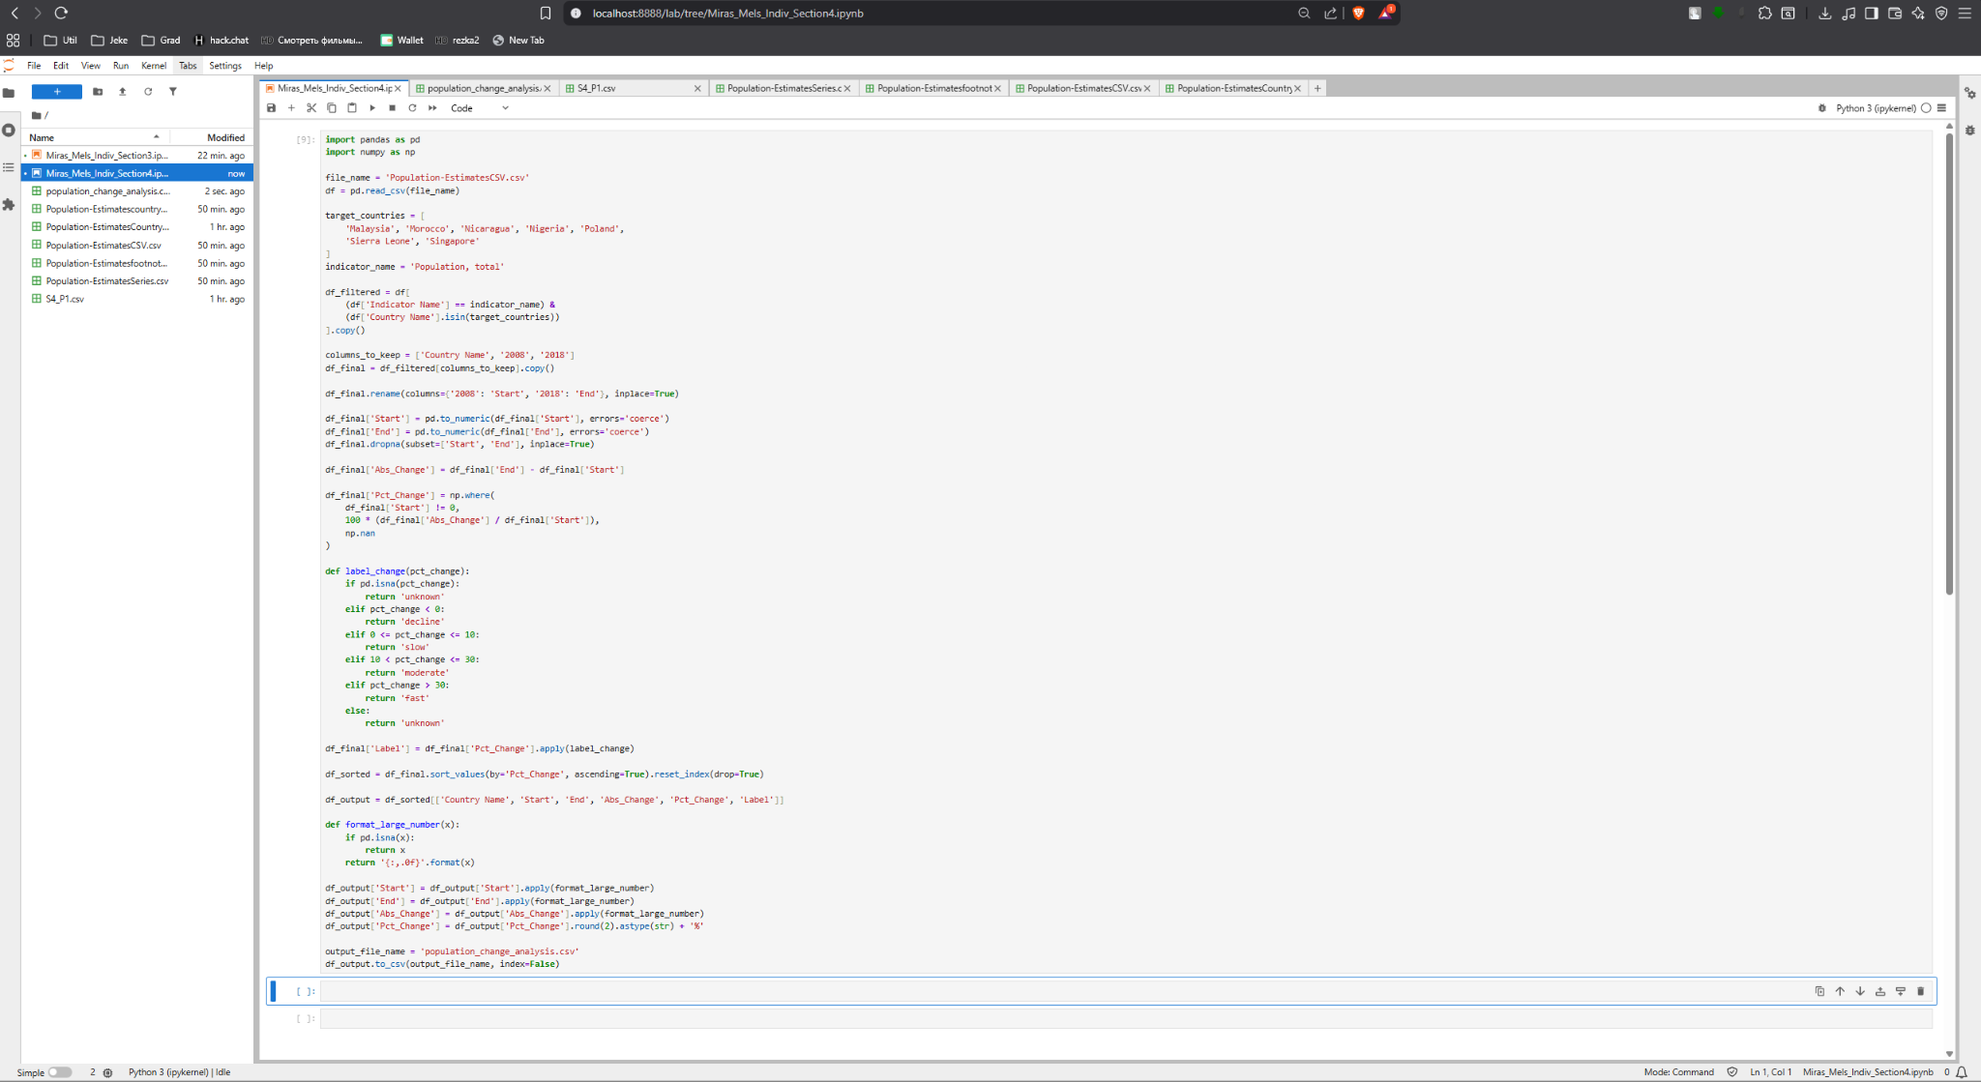
Figure 8. Screengrab of Jupyter Lab python code.
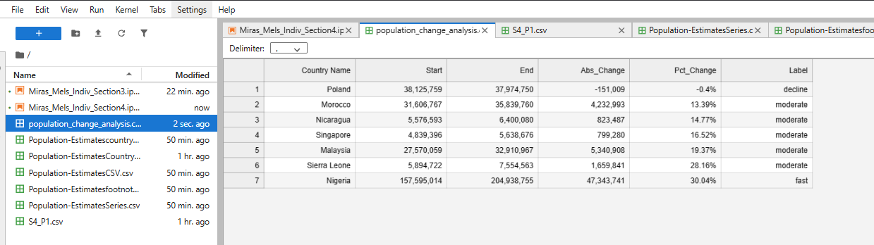
Figure 9. Screengrab of output table for Q1.
For Question 1, I have selected 7 countries: Malaysia, Morocco, Nicaragua, Nigeria, Poland, Sierra Leone, Singapore. And the years 2008 and 2018(the year of the world bank crisis and 10 years after that). From the selected countries, only Nigeria indicated fast population growth, while only Poland demonstrated decline in population in the selected decade. Other countries, to my surprise, showed moderate growth in population, whilst I guessed the majority would indicate rapid growth.

Part 2. Strings.
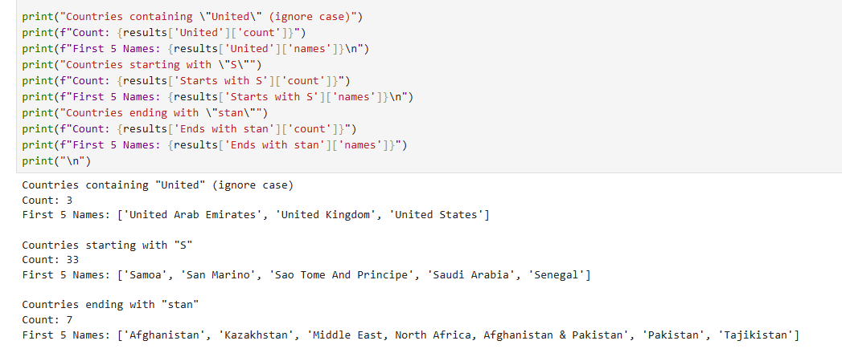
Figure 10. Screengrab of the python code output.

Countries containing "United" (ignore case)
Count: 3
First 5 Names: ['United Arab Emirates', 'United Kingdom', 'United States']

Countries starting with "S"
Count: 33
First 5 Names: ['Samoa', 'San Marino', 'Sao Tome And Principe', 'Saudi Arabia', 'Senegal']

Countries ending with "stan"
Count: 7 First
5 Names: ['Afghanistan', 'Kazakhstan', 'Middle East, North Africa, Afghanistan & Pakistan', 'Pakistan', 'Tajikistan']

It is interesting to note that the filter for names ending in "stan" picked up a non-country regional grouping ('Middle East, North Africa, Afghanistan & Pakistan'), highlighting that the data contains aggregates in addition to sovereign nations.

Part 3. Decisions and Loops.
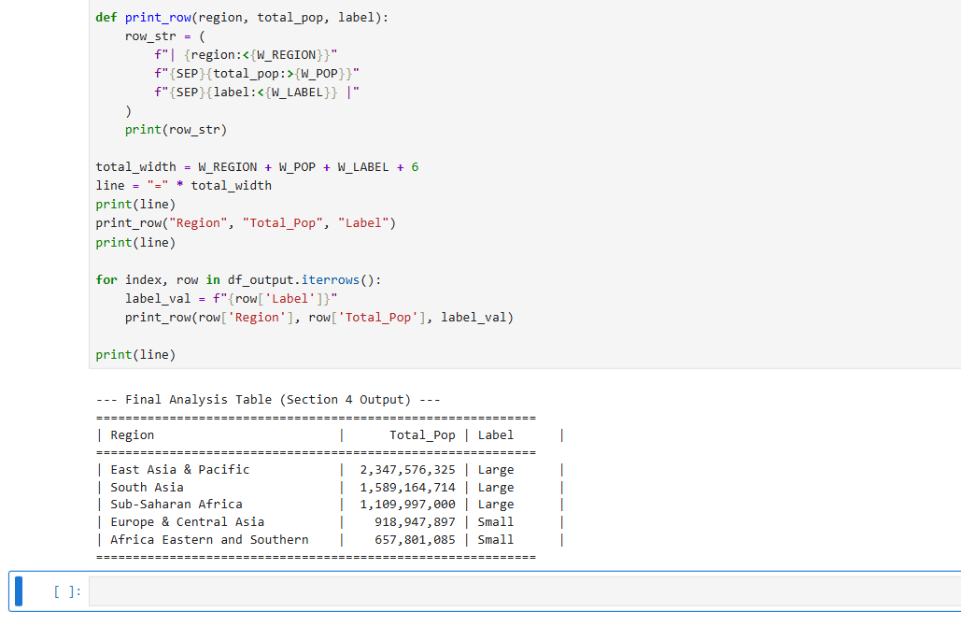
Figure 11. Screengrab of the code output.
The one-billion threshold was chosen to clearly separate the world’s largest population groups from all others. It’s a natural, easy-to-understand cutoff because only major global regions reach the billions, making the “Large” label meaningful, consistent, and simple.
The main challenges were data structure ambiguities (manually identifying geographical regions in a column that lacked a specific 'Region' label) and output formatting issues (the inability to use the standard pandas markdown function due to a missing library dependency). I solved these by using explicit filtering lists to correctly categorize the data and by developing a custom Python printing routine with f-string padding to generate a clean, fixed-width ASCII table.

Section 5.

Part 1.
A line chart is best for this analysis because it shows trends over continuous time, highlighting changes in direction, rate, and magnitude across years of population data.
The visualization reveals clear differences among the seven countries:
- Nigeria shows extremely rapid, exponential population growth, rising from about 40 million in 1960 to over 215 million in 2022.
- Morocco, Malaysia, and Sierra Leone display steady, consistent growth.
- Nicaragua and Singapore have the smallest populations, growing slowly but reliably.
- Poland remains mostly flat, with its population staying between 30 and 40 million, indicating near-stagnation compared to the others.
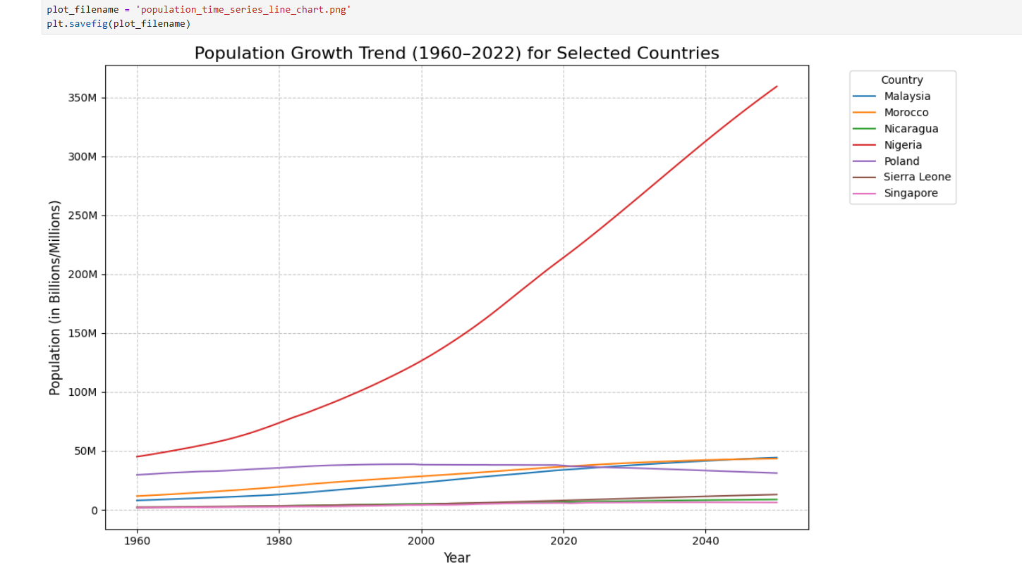
Figure 12. Screengrab Line graph of previously chosen countries’ population dynamics.

Part 2.
I conducted a multi-step demographic analysis involving calculations, string pattern matching, and the application of a population threshold to classify major regions. I then created two visualizations: a line chart to illustrate population trends over time and a bar chart to compare the population ranking of the top 10 sovereign countries.
My main challenge was ensuring data integrity and filtering accuracy, as I had to iteratively refine regular expressions to strictly exclude all non-country aggregates (economic, regional, and demographic groupings) from the analysis. A second technical hurdle was the inability to use standard pandas markdown functions due to a missing dependency, which I overcame by implementing custom, fixed-width string formatting for the tabular output.
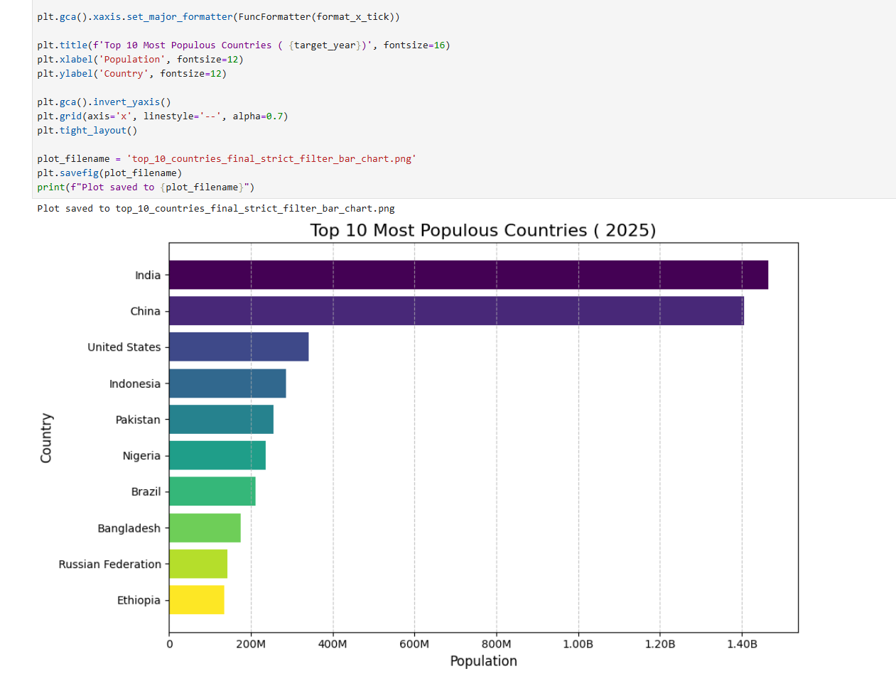
Figure 13. Screengrab of the bar chart of countries by population with a code snippet above.

Part 3.
A histogram shows the distribution of a continuous variable by grouping population sizes into bins and revealing their frequencies. Using a log scale exposes the extreme right-skew: most countries have very small populations. The tallest bars appear in the lowest population ranges, showing strong concentration at the bottom. Very few countries have populations above 100 million, and only China and India exceed one billion. The overall pattern is not normal but follows a power-law distribution, where small populations are common and large ones are rare.
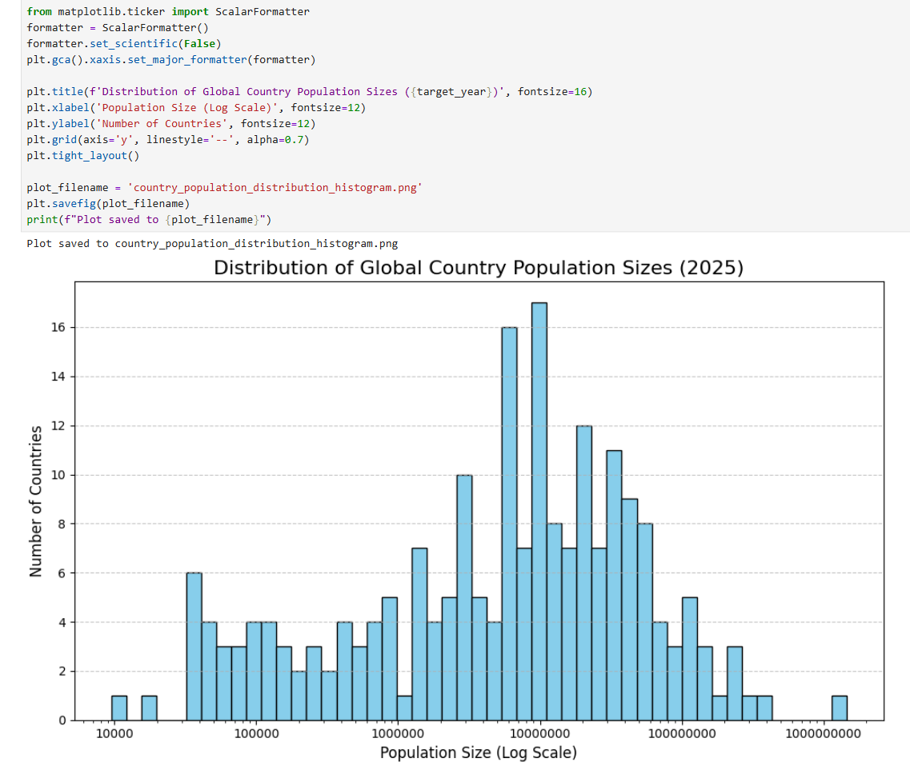
Figure 14. Screengrab of the Population Distribution Histogram with a code snippet above.
When I first looked at the histogram, it seemed to show only one country in the “above one billion” population range, but that’s actually a binning illusion. In reality, both India and China exceed one billion, yet their populations are so close that they fall into the same final histogram bin on the logarithmic scale. After checking the bin counts, I noticed that the rightmost bin actually contains two countries, covering roughly 1.12 to 1.425 billion. Because the histogram groups values into contiguous ranges rather than listing them individually, the two countries appear as a single bar. So the chart isn’t missing a country—it’s just aggregating both giants into the same bin.

Section 6.

Part 1.
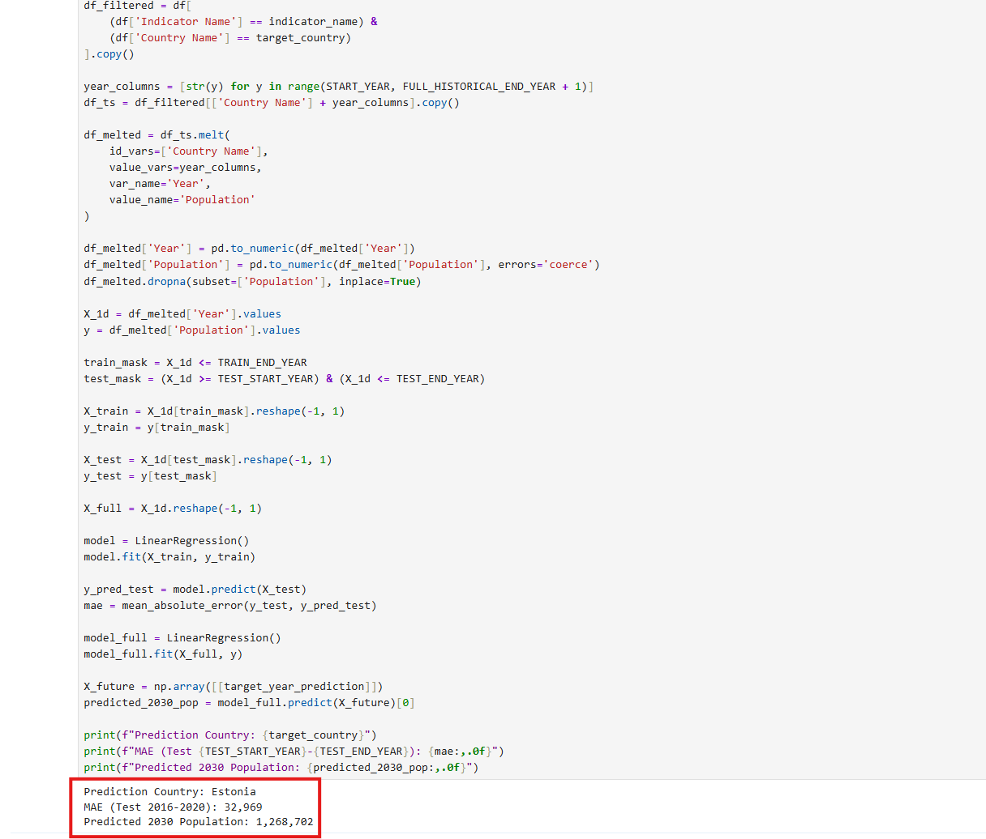
Figure 15. Screengrab of the task one outputs.

Part 2.
I trained a linear regression model on Estonia’s population data from 2000–2020, and based on that, I obtained a 2030 population prediction of 1,268,702. I also evaluated the model by testing it on the 2016–2020 period, where I calculated a Mean Absolute Error (MAE) of 32,969, meaning my estimates were off by about 33 thousand people on average. Since Estonia’s population is just over one million, I found this error to be relatively small in proportional terms. Overall, I’ve confirmed that the linear model I used provides a reasonably solid fit for Estonia’s short-term population trend.

Part 3.
I think an excellent alternative model would be Polynomial Features combined with Linear Regression. I think this approach works well because it transforms the single feature (Year) into multiple polynomial terms (Year, Year², Year³, etc.), and then I can train a standard linear regression model on these expanded features. I believe this is appropriate because population growth often behaves more exponentially than linearly, and the polynomial terms help capture that curvature. I think this allows the model to follow Nigeria’s accelerating growth pattern more closely. Because of this added flexibility, I think the polynomial model would likely produce more accurate predictions by better representing the underlying non-linear demographic trend.

Section 7.

Part 1-2.
I developed a K-Nearest Neighbors (KNN) classification model using metadata features from the country data, which I first one-hot encoded to convert categorical data into numerical features. The main challenges during data preparation involved safely handling missing data and resolving the SettingWithCopyWarning using explicit copies and the .loc accessor. Finally, I split the data into training and testing sets using a stratified split (stratify=y) to guarantee that the four target Income Group classes were represented proportionally in both the training and testing datasets, ensuring a balanced evaluation.

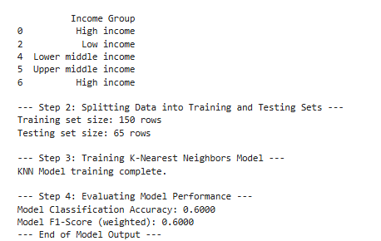
Figure 16. Screengrab of the model output.

Part 3. Predictions and error explanations.
By using the KNN classifier to predict a country's Income Group—a categorical label indicating its economic status (Low, Lower-middle, Upper-middle, or High). I first prepared the categorical features like Region and Lending category by applying one-hot encoding, resulting in 17 binary numerical features used for prediction. The classification accuracy of 60.00% means the model correctly predicted the Income Group for $60$ out of every $100$ countries in the test set. The weighted F1-Score of 0.5911 confirms this result, telling you that the model has moderate performance across all four income groups.

Part 4. Advantages and disadvantages of KNN
KNN is a simple, non-parametric method that works well when the classes are clearly separated, which we can see from the good results here. It also does not need a real training phase because it just keeps the whole dataset.
But in this case, its drawback is that with 17 features, it can be affected by the “curse of dimensionality.” When there are too many features, the points become too far from each other, and distance measures stop working well. This is likely one reason why the accuracy is only around 60%. The model also becomes slower on larger datasets because it must calculate distances for every point.
This basic binary split did not show anything new, but a more detailed classification (for example, by Income Group) could. With that, KNN could show which demographic factors make countries similar and help predict possible changes between income groups. These early predictions could support more proactive policy planning.

Section 8

Part 1.
The Decision Tree Classification task is complete, and the model performed well.
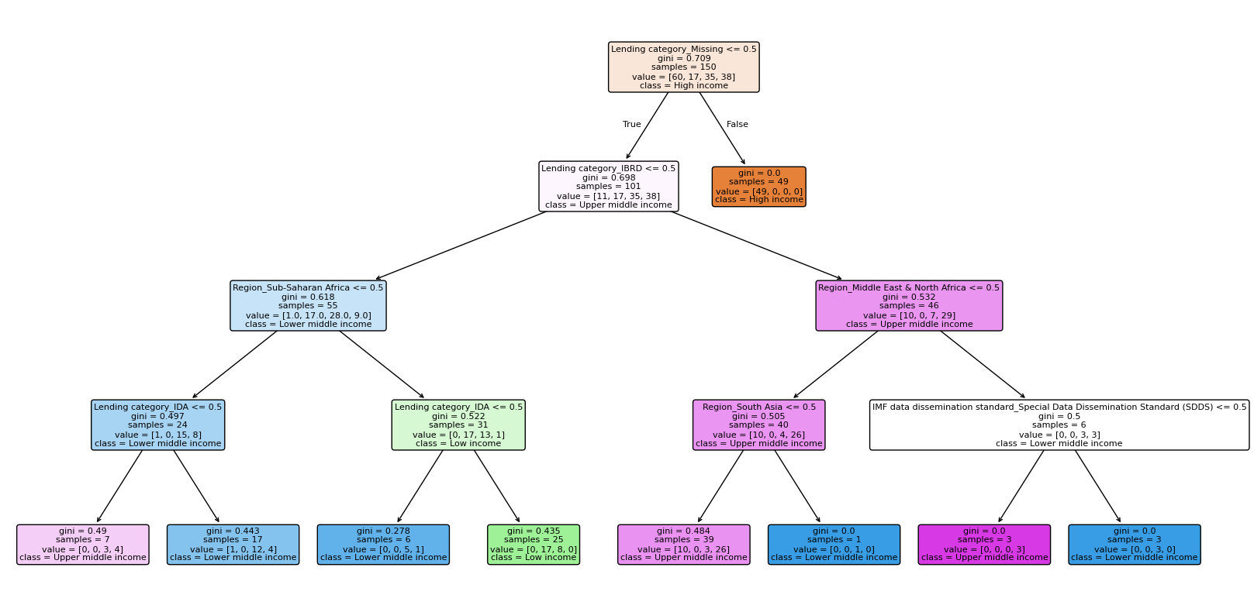
Figure 17. Screengrab of the decision tree model output.

Part 2.
I chose the stratified train/test split (stratify=y) to ensure that the distribution of the target variable, Income Group, was maintained identically in both the training and testing sets. This is critical for evaluating classification models, especially with unevenly distributed classes, because it guarantees the test set is a fair and representative sample of the data.

Part 3.
I trained a Decision Tree classifier to predict a country's categorical Income Group using 17 binary features derived from country metadata, such as Region and Lending category.
The classification accuracy of 69.23% means that 69 out of every 100 countries in the test set were correctly assigned to their appropriate Income Group based on the logical rules learned by the tree. The weighted F1-Score of 0.6928 confirms this level of performance, indicating that the model is moderately effective and consistent in its predictive capability across all four distinct income groups.

Part 4.
Using a Decision Tree model here has strong points and weak points. A big advantage is its interpretability; the model is like a flowchart, so I can easily see and understand the exact rules it uses to predict an Income Group. This makes it a "white box" model, not a confusing "black box."
A main disadvantage is that Decision Trees can easily overfit the training data, meaning they learn the training set too well and might not work accurately on new, unseen countries.
The structure of the tree reveals new relationships because the splits show the hierarchy of features; for example, if the first split is on Lending category_IDA, I know this is the single most important factor, and I can see how its effect changes based on subsequent features like Region. Using these predictions supports more effective strategies by giving a clear, actionable path: if the model predicts a country will become "Upper-middle income" based on its characteristics, policymakers know exactly which combination of regional status and accounts systems are already working for that group, allowing them to proactively support those key characteristics.

